**PYTHON OVERVIEW**

The **Python** **programming language** is an object-oriented language, which means that it can model real-world entities. It is also dynamically-typed because it carries out type-checking at runtime.

The distinctive feature of Python is that it is an interpreted language.

Python is Interpreted − Python is processed at runtime by the interpreter. You do not need to compile your program before executing it. This is similar to PERL and PHP.

**Python Installation**

* $sudo yum install -y python3
* export PATH="$PATH:/usr/local/bin/python"

**Python IDE**

* IJ
* PYTHONCHARM

**Python Architecture**

* **Parser**
* It uses the source code to generate an abstract syntax tree.
* **Compiler**
* It turns the abstract syntax tree into Python bytecode
* **Interpreter**
* It executes the code line by line in a REPL (R*ead-Evaluate-Print-Loop) fashion*

## Features of Python

## Python is very easy to learn and understand; using this Python tutorial, any beginner can understand the basics of Python.

* Interpreted
* It is interpreted(executed) line by line. This makes it easy to test and debug.
* Object-Oriented
* The Python programming language supports classes and objects

## Free and Open Source

## Portable

## You can use it to develop a GUI (Graphical User Interface). One way to do this is through Tkinter

## Python provides you with a large standard library. You can use it to implement a variety of functions without needing to reinvent the wheel every time

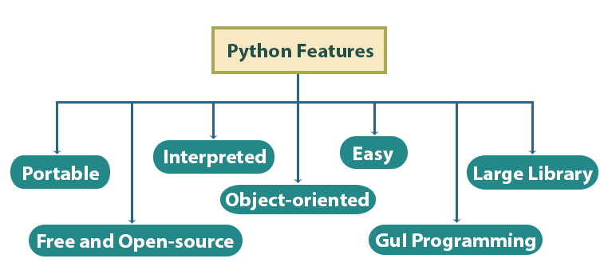

## Python Frameworks

### **Django** It allows you to create database-driven websites.

### **Flask** [**Flask**](https://data-flair.training/blogs/python-flask/) is a web framework written in Python itself. It is a **micro framework** because it does not need certain libraries and tools.

### **Pyramid** Pyramid is another web framework

### **Tornado** Another open-source web framework. It is noted for its excellent performance and scalability.

### **Bottle** Like Flask, it is a micro-framework for Python. It is used for web development

### **web2py** web2py is another open source web framework

### **NumPy** We use it for scientific computing. It supports large multidimensional arrays and matrices, and functions to operate on them.

### **SciPy** use for scientific computing

### **File Extensions in Python**

* **.py –**The normal extension for a Python source file
* **.pyc-** The compiled bytecode
* **.pyd-** A Windows DLL file
* **.pyo-** A file created with optimizations
* .**pyw-** A Python script for Windows
* **.pyz-** A Python script archive

**Python Applications**

* Build a website
* Develop a game
* Perform Computer Vision (Facilities like face-detection and color-detection)
* Implement Machine Learning (Give a computer the ability to learn)
* Enable Robotics
* Perform Web Scraping (Harvest data from websites)
* Perform Data Analysis
* Automate a web browser
* Perform Scripting
* Perform Scientific Computing
* Build Artificial Intelligence

Interpreted vs Compiled Programming Languages